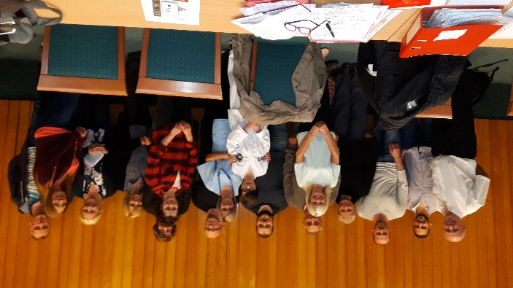

Welcome to the third Beach Lane Tenants and Residents Association (2020) Annual Report.
Firstly, I would like to thank everyone who has attended and supported the group over the last three years. Secondly, a special thank you to the Office Bearers and Committee Members, who have helped and supported me through many ongoing issues, and also our successful achievements over the last year.
Over the last year we have managed to address most of the issues highlighted at the recent Estate Inspection (2019).
One of our top priorities (now that the communal stair has been decorated), is the installation of CCTV cameras. The cellars in the stairwells and entrances to stairs are now in the process of being cleared out. This is to enable Tenants and Residents to store prams and buggies; which can be securely stored.
Unfortunately, we have an ongoing issue with water ingress through the outside balconies. At this present time we are working in partnership with East Lothian Council to resolve these issues.
Achievements over the last three years:
- Front door, security, intercom
- Security door fob keys
- Main stairs, walkways, landings, ceilings (all decorated)
- Balconies (water ingress) ongoing
- Cellars at entrances to building and communal stairs (being cleared and secured for storage of prams, etc.) ongoing
- Bin cages (all secure and uniformed)
- Tarmac at garage area (all renewed)
- Stair.street lighting (all in working order)
- Fly tipping/rubbish (constant issue but dealt with ASAP)
- Planters (tidied out and trimmed back) seasonal work
Future achievements:
- Installation of CCTV cameras in stairs
- Ballustrades (in front of building) to be repaired
- Roof maintenance (to be considered)
The community spirit has escalated over the last year, but there are still a few small niggles that are currently being addressed.
Our main aim of the group is to raise the profile of the Beach Lane area, so that people will admire and talk about the changes to the area, on their journey to the beach.
I would like to thank everyone who has attended our meetings on a regular basis. Major thanks go to Sue Cairns (East Lothian Tenants and Residents Panel), Brian Mills (Housing Officer), Kenny Black (Safer Communities Team) and Andy Forrest (Councillor). Without these people helping and supporting us through many major issues, we would not have achieved many of the goals over the last three years. They are all very supportive and at the other end of a phone, or e-mail, to help us combat major problems, many thanks once again to you all. Many thanks also to our Office Bearers and Committee Members who help and support me, through the highs and the lows of many issues.
Our meetings are open to everyone and we are always very eager to welcome new members.
My hope for next year 2020/2021 is that we will be more successful in our ongoing achievements, and try to escalate more social and community events. Once again many thanks and hope that this is the biggest and best year for the group.

Many Thanks
Linda Finlayson (Chairperson)

